# Intro

Historically, Tencent stock prices have outperformed all other comparable stocks in terms of growth. Tencent was one of the 10th biggest company in the world by market capitalisation at its peak (Nishizawa & Costa, 2018). Its share price has surged for 67000% in 14 years since first listed in Hong Kong Stock Exchange in 2004. 68% of Tencent's revenue is from smartphones games, which equals to 21.7 Billion RMB from the biggest hit "Honour of the Kings" in the first quarter of 2018 (Tencent Holdings Limited , 2018). Nevertheless, the tech giant faced a formidable challenge in their gaming business in 2018 following Chinese gaming sector reforms. Its share price tumbled 40%, wiping out net worth of more than 220 billion USD in 10 months, in comparison (Costa, 2018), Netflix's net worth is $162 Billion.This paper will look for evidence of the extent to which these reforms were the cause of the fall in Tencent share price, as well as testing the market efficiency in these events. To the best of my knowledge, this is the first rigorous study of the impact of gaming regulations on Chinese tech firms that rely heavily on gaming revenue.

In this paper, the significance of government interventions will be discussed. The paper will first start off by reviewing previous literature about event study and the related financial theory, follow with the examination of the method of the event study. Description of the general atmosphere and the data will be presented in the subsequent session. The result of the model estimation and hypothesis will be detailed in the next session. Further hypothesis testing will subsequently be carried out for scrutinising the magnitude of the impact of the government. Lastly, the limitation of the research and future agenda will be deliberated, and the paper ends with the concluding discussion.

# Literature Review

Efficiency Market Hypothesis

Capital markets serve as a medium for transferring funds between lenders and borrowers, and a capital market said to be efficient when prices are fully and instantaneously reflected on all available information (Firth & Keane, 1986). Malkeil (2003) further stressed that efficiency with respect to an information set, it is impossible for investors to earn economic profit by trading on previous information, as it had already been instantaneously reacted by the market when the information was first released. An efficient market will allow the security price to provide accurate signals for resource allocation, where private firms access to credit in efficient price, and implies that it is impossible to earn superior rates of return consistently unless by chance. Capital market efficiency is divided into 3 categories:

* Weak form: Prices incorporate all information contained in past returns. This implies strategies that are based on historical share price or other financial data will not generate any excess return, where investment returns will not be greater than risk-free rate in, the long run.
* Semi-strong form: Prices incorporate all publicly available information. This implies no excess return can be earned by trading on that information as share price adjust instantaneously and unbiasedly.
* Strong form: Prices incorporate all privately and publicly available information. This implies no one can earn excess return on any information.

It is generally accepted that weak form exists in the stock market. In an efficient capital market share prices only change when new relevant information arrives, and as this information is unpredictable price changes are also unpredictable (this is the so-called “random walk”). There is a general consensus that markets are at least weak-form efficient, which is mentioned in the findings from Brealey (1970) , Cummingham (1973), Dryden (1970b) and Girmes and Benjamin (1975) (cited in Firth & Keane, 1986). Additionally, studies by many economists, including Firth (1976a, 1979, 1980), Keown and Pinkerton (1981), Kraus and Stroll (1972), Scholes (1972) (cited in Firth & Keane, 1986) conclude that markets are also semi-strong form efficient most of the time. With regards to strong form efficiency, most studies appear to conclude the markets are not strong form efficient (Neiderhoffer and Osborne, 1966, Collins, 1975, Jaffe, 1974 and Finnerty, 1976 as cited in Firth & Keane, 1986), implying investors can earn profits on inside information.

Despite the efficient market hypothesis is long-standing and substantial amount of empirical research on the hypothesis had been carried out throughout the history, anomalies persist in the market which contradict the efficient market hypothesis. Therefore, this paper will examine if the market has acted efficiently in the case of Tencent stock.

Anomalies

Efficient market hypothesis stated that share prices are random walk and thus unpredictable from past price behaviour. However, a seasonal pattern is observed in the stock market where the average monthly return is significantly higher in January than in other months (Thaler, 1987). Half of the excess return came from January and half of excess return in January came from the first five trading days of January (Keim 1983 cited in Thaler,1987). The effect is most viable in the price of small firms and firms which their share prices were slumping continuously in the past years, as well as risky stocks earn the most of their risk premium in January. Similar patterns are also noticed in the weekend which is studied by Cross (1973), French (1980) and Rogalski (1984). Transaction day before the holiday also displayed a higher mean return than the others, known as the holiday effect (Thaler R. H., 1987). In other words, the predictable patterns indicate prices can be predicted by past behaviour and thus is inconsistent with the efficient market hypothesis. Nevertheless, these effects are not dependable and not exploitable as they are very small relative to the transaction costs involve; arbitrage opportunities were not offered to investor for generating excess risk adjusted returns (Malkiel, 2003). Moreover, the event study is analysing the relative movement of the stock and the market. Any persisting time effect will affect the stock and the market equally and thus it will not affect the inference.

On the other hand, the effect of stamp duty on equity transaction and price was examined in a discussion paper in from Bank of England. The result has shown reduction in stamp duty leads to significant increase in volume of transaction and equity prices (Jackson & O'Donnell, 1985). However, the stamp duty would not be a concern when it is assumed that every investor faces the same transaction cost. This implies investors will not alter the choice of investment, in terms of choice and the volume, as the transaction cost remain the identical for investors and thus the share price would not be affected by the difference in transaction cost.

Event Study

The joint probability test of the significance of the government interventions to the share price of Tencent and the market efficiency can be carried out by the statistical method of Event Study. An event study measures the impact of an event on the value of the firm. With the event study, the effect of the event can instantly be reflected on the share price by the abnormal return, the difference of actual share price with the predicted share price where no new information was released, given the rationality of market (MACKINLAY, 1997). It had been widely used in the academia for evaluating price changes. Throughout the decades, the methodology has improved by removing market return and confounding events. Methodology of modern event study is largely built on the foundation of the seminal studies by Ray Ball and Philip Brown in 1968 and Eugene Fama et al in 1969 (MACKINLAY, 1997). This analysis loosely follows the outline suggested by Event Studies in Economics and Finance by A. Craig MacKinlay (1997), which will be further discussed in the latter section.

Model Selection

The predicted stock price can be carried out by a model including the market model, which will be further discussed in the latter chapter. Both constant mean model and the capital asset pricing model (CAPM) were considered for the study. Nevertheless, CAPM outperforms constant mean model and more complicated models perform similarly with simple models as none of the models can effectively reduce the variance of the abnormal return (MACKINLAY, 1997). Having said that, the market model is more precise as it reduces the variance of the abnormal return by deducting the return of the stock generated from the fluctuation of the market. To that end, the market model is an improvement of the constant mean model which serves as a better model for event study (MACKINLAY, 1997).

CAPM demonstrates the relationship between the investment risk to the rate of return of an asset. Yet according to Mackinlay (1997), anomalies of CAPM cause the model to be sensitive under CAPM criterion. In comparison, such anomalies do not exist in the market model and thus the market model is preferred to deliver a more accurate result.

# Method

To conduct an event study, the initial task is to identify the event and set up the event window. The event window is the period from the day the event occurs to a few days afterward. This allows the impact of the event to be captured after the stock market closed as well as the reaction of investors a few days after the event. Since Tencent is the largest stock listed in the Hang Seng Index by market capitalisation, it is assumed that it has a high information flow and investors can quickly react to the news toward Tencent. Thus, the event windows are set as 4 days from the events occurred. The reference index is introduced to the event study to deduct the returns generated from the movement of the market. This enhances the ability to evaluate the impact as this captures the net impact of the events from the market variation.

The estimation window is established to calculate the predicted return of the stock price. This is typically a 120 days period prior to the event to derive the relationship between the stock price and the reference index. However, in this analysis, the 30 days before the event is neglected to avoid the possibility of information leak. Therefore, the 120 days estimation window is created from 150 to 30 days before the events.

Estimation WIndow

Event Window

(Neglected)

-150

5

0

-50

However, for this event studies, as the interval between all the events were short, only one estimation window is needed for all the events without statistical bias.

Log return can be calculated by deducting the natural logged adjusted closing price of a day with the previous day. The predicted return can now be obtained with the market model through regression of the return of stock and market in the estimation window. The market model is a statistical model that assumes the relationship between stock price and the market index are linear correlated. The market model equation for stock i is as shown:

$$R_{i}= α+ βR_{m}+ ε$$

where Ri, Rm indicate the return of the stock i and the market respectively, α, β are both parameters and ε is a zero-mean disturbance. Inserting the market return from the event window to the regressions’ coefficients create the predicted return of stock price on each day of the event window. Hence the abnormal return (AR) can now be computed by deducting the predicted return from the actual return,

$${\hat{AR}}_{iτ}=R_{iτ}- {\hat{α}}_{i}-{\hat{β}}_{i}R_{mτ}$$

$R_{iτ}$ and $R_{mτ}$ are the actual return of stock i and the market on a specific day τ in the event window, while ${\hat{α}}_{i}$ and ${\hat{β}}_{i}$ are parameters from previous regressions. Average abnormal return (${\overline{AR}}_{τ}$) can also be computed by summing up all abnormal return on a day and divide it by the number of events N.

$${\overline{AR}}_{τ}= \frac{1}{N}\sum_{i=1}^{N}{{\hat{AR}}_{iτ}}$$

On the other hand, cumulative abnormal return (CAR) is the sum of included abnormal returns in the period τ1 to τ2, where T1 < τ1 ≤ τ2 ≤ T2.

Cumulative average abnormal return ( $\overline{CAR})$ is the sum of all included AAR in period τ1 to τ2.

With the null hypothesis of the abnormal returns equals zero, a Student T-test can be implemented to test the significance of the null hypothesises. The t-stat can be composed by dividing the abnormal return by the root mean square error of the regression. By contrast, CAR can be tested by dividing the CAR of the last day in the event window by the product of mean square error and the square root of the length of the event window. For instances, the t-stat of testing the CAAR can be calculated by the following equation.

$$θ=\frac{\overline{CAR}(τ_{1}{,τ}_{2})}{{var(\overline{CAR}(τ_{1}{,τ}_{2}))}^{1/2}} \sim N(0,1)$$

# General atmosphere and data description

Notwithstanding the 3 events chosen for this analysis, investors had been pessimistic towards Tencent and the gaming sector in 2018. Tencent's share price ended its 14 years surge in January and had shown a downward trend since March 2018, after major shareholder Naspers sold 2% stock of Tencent, accounted for $9.8 billion USD. Along with the redemption, Tencent was not able to monetise from one of their biggest hits, PlayerUnknown's BattleGround (PUBG), despite having a massive player base. Mobile games profit largely relies on purchasing in-game currency and selling in-game items, including PUBG, where the game is free for download. However, the license for activating in-game sale was held by Chinese regulators for months after the announcement of the game in 2017's November and Tencent were uncertain when they would get the approval (Ma, 2018). Simultaneously, no new game license was issued by the Chinese regulators since March after the restructuring of the license agencies. In China, a game cannot be published until a gaming license is issued from the regulators, and a suspension of gaming license approval implies drastic hinder the revenue of new game launches. Tencent's struggles were reflected in the second quarter report in 2018, revealing a missing in profit target and fall in profit growth for the first time in a decade (Mozur, 2018).

Having said that, 3 key events were directly targeted to Tencent and the gaming sector in 2018.

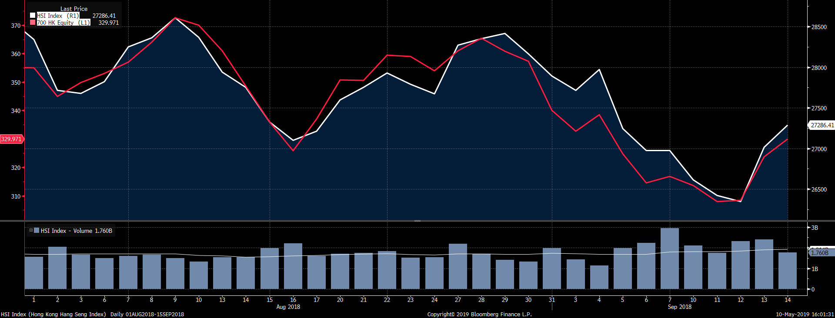

The first event consists of the major hit of Tencent, Monster Hunter. On 13th August, the highly anticipated game with 1 million pre-orders was forced to pull down days after its release by Chinese regulators. The share price dropped 3.71% on the next day of the announcement, wiping out $15 billion USD. Originate from Japanese developer Capcom, the game, which allows the player to battle fearsome fantasy beasts, was meant to be the flagship of Tencent's distribution platform WeGames. Users who paid for the game were fully refunded "without a condition (Hancock, 2018). That said, the operating license was cancelled at the request of authority as it failed to "fully comply with regulatory and policy requirement" and a flood of complaints was sent to the regulators (WeGames, 2018). The game contains blood and violence, and the Chinese government often ban games with sensitive content including excessive violence, usage of drugs and sex. In spite of that, it is extremely rare for games to be banned after permitted (BBC, 2018). The game as well does not contain any sort of obviously sensitive content (Hancock, 2018), which leaves the true motive of the banning to remain uncertain. The event alludes the abrupt and haphazard regulatory measure of the government and their influences where they can singlehandedly affect the profitability of Tencent, even after the games passing the censor. Furthermore, the halt of sales cast a long shadow towards the future prosperity of Tencent. Monster Hunter was the key to boost sales of WeGame in order to compete with its rival gaming platform, Steam (Huang, 2018). Yet putting off the game implies Tencent has lost their best chance to compete with Steam.

On 31st August, Chinese regulators blamed mobile games as the major reason for worsening rate of myopia and suggested multiple measures to curb on the issue. Tencent's share fell for more than 5% on the next day (Woodhouse, 2018). In the pronouncement from Ministry of Education, policy plans for limiting the number of online games and the game time for young people were established, as well as developing an age-appropriate system for mobile games (Ministry of Education, 2018). It suggested "the use of electric product for non-learning purposes should not exceed 15 minutes and should not be more than one hour per day" (Nakamura, 2018). Despite the pronouncement seemingly subject to improvs the rate of myopia and the wellbeing of the children, the timing of the pronouncement drives the investors pinpoint on the measure for the gaming sectors. The government did not provide any explanation of the gaming freeze since March, investors started to question whether the freeze is merely a regulatory reshuffle, or the regulators were planning on a bigger campaign on cracking down the gaming industry (Nakamura, 2018). In order words, the pronouncement does not merely imply the regulatory risk is heightened, but it created speculations of the government attitude towards the gaming sector would gradually become more adverse in the future.

On 5th September, Tencent responded to the pronouncement by setting up a real name verification for new players in their biggest hits "Honours of Kings", which is linked to the Public Secretary database to restrict game time. "The strictest verification system" named by Tencent was going to be implemented on 15th September. The announcement caused a 3.7% fall in Tencent's share price on the next day (Lockett, 2018). New users' identity would be linked to data from the public secretary authority during the time of registration and the system would able to detect whether the new users were minors. Newly registered minors would then be included in the "anti- addition system" and their game time would be limited (Stand News, 2018). Despite it was not mentioned how or whether current users will be affected by the new system (Lockett, 2018), the implementation of the real name verification system discourage new players by increasing the barrier, which in turns reduce the potential growth of profit. This is the first real name verification with public secretary database to be implemented in the gaming industry but Tencent would gradually expand the verification to other Tencent games once it succeeded in "Honours of Kings" (Deng , 2018).

# Model Estimation and hypothesis testing

First event

The first event consists of an event window of 13th August to 16th August and an estimation window from 12th March to 12th July 2018. The relationship between return of Tencent and the return of the market, Hang Seng Index in the estimation window of the first event is shown from the result. The abnormal equation for the first event can be set as follow:

$${\hat{AR}}_{iτ}=R_{iτ}+ 0.0007-1.3114×R_{mτ}$$

By inserting the return of Tencent and market return on each day of the event window to the equation, the AR and CAR can be calculated. The result is as shown in the following table.

|  |  |  |  |  |  |  |
| --- | --- | --- | --- | --- | --- | --- |
| Date | ln_ret | ER | AR | AR Beta | CAR | CAR Beta |
| 13/08/2018 | -0.02463 | -0.02071 | -0.00392 | -0.36458 | -0.00392 | -0.18229 |
| 14/08/2018 | -0.03495 | -0.00933 | -0.02563 | -2.38303 | -0.02955 | -1.37381 |
| 15/08/2018 | -0.03681 | -0.02112 | -0.01569 | -1.45879 | -0.04523 | -2.1032 |
| 16/08/2018 | -0.03083 | -0.01145 | -0.01938 | -1.80214 | -0.06461 | -3.00427 |

From the table ln-ret represents the log return of the day and ER, AR and CAR represent the expected return, abnormal return and the cumulative abnormal return of the day respectively. AR Beta and CAR Beta represent the t-stat for AR and CAR respectively. Since all the events negatively influence on Tencent, the actual return would be smaller than the expected return, if the event had an impact on the share price. The event happened in the morning of 13th August and the market was able to react on the same day, despite by the small magnitude of abnormal return of -0.004. Given the root of mean-squared error for the regression on the first event is 0.01075, the value of θ is -0.3721 and it failed to reject the null hypothesis of the event has no impact on the share price of Tencent. However, the AR plunged on the day after the event with -0.02563, implying Tencent’s stock return aligned with the market return until the day after the event, suggesting a response lag in the market. The value of θ for day 1 decreased to -2.3830 and the null hypothesis is strongly rejected. This implies the market did not instantaneously respond to the event on day 0. A possible reason is stock market may not be efficient and investors are still digesting the information, which will be further discussed in the later session. It can also be interpreted as investors were expecting Tencent to release statements regarding working on a fix for the game and will re-release the game in future, but Tencent remained silent and the investors ran out of patience on the next day. The CAR on the last day of the event window is -0.06469, with the value of θ -3.008, evincing strong evidence against the null hypothesis of the event having no impact on the overall share price in the event window, despite having no effect on day 0.

Second Event

The second event consists of an event window of 31st August to 5th. The result for AR and CAR is as shown in the following table.

|  |  |  |  |  |  |  |
| --- | --- | --- | --- | --- | --- | --- |
| Date | ln_ret | ER | AR | AR Beta | CAR | CAR Beta |
| 31/08/2018 | -0.04991 | -0.01357 | -0.03634 | -3.37983 | -0.03634 | -1.68992 |
| 03/09/2018 | -0.0214 | -0.00898 | -0.01242 | -1.15511 | -0.04877 | -2.26747 |
| 04/09/2018 | 0.01728 | 0.0116 | 0.00567 | 0.52745 | -0.04309 | -2.00375 |
| 05/09/2018 | -0.04161 | -0.03533 | -0.00628 | -0.5837 | -0.04937 | -2.2956 |

The notice from the Ministry of Education was announced in the evening of 30th August and the market reacted on the next day. The AR on day 0 was -0.0.3634, the value of θ is -3.37983. This suggests the null hypothesis of the second event does not have an impact on the share price is rejected. Among the whole event window, the AR on day 0 is the lowest, which also insulates the market quickly reacted on the event without a visible lag. This suggests a strong evidence in favour of the existent of semi-strong form in the capital market, where the price react to the new information instantaneously. The CAR on the last day of the event window of the second event is -0.04937, leading to θ equals -2.2956. In other words, the impact of the second event on the share price of Tencent is statistically significant. Since the market reacted the most on day 0, and the AR gradually follows the trend of the market return, it has demonstrated the market efficiency is achieved in the second event.

Last event

The last event took place on the evening of 6th September and the market reacted on the next day, with the event window of 7th September to 12th September. By adding the return of the market and the actual stock price from the event window of the last event, the AR and CAR can be computed as shown in the following table.

|  |  |  |  |  |  |  |
| --- | --- | --- | --- | --- | --- | --- |
| Date | ln_ret | ER | AR | AR Beta | CAR | CAR Beta |
| 07/09/2018 | 0.00697 | -0.00074 | 0.00771 | 0.71735 | 0.00771 | 0.35868 |
| 10/09/2018 | -0.01015 | -0.0183 | 0.00815 | 0.75803 | 0.01587 | 0.73769 |
| 11/09/2018 | -0.01802 | -0.01012 | -0.0079 | -0.73486 | 0.00796 | 0.37027 |
| 12/09/2018 | 0.0013 | -0.00453 | 0.00583 | 0.54211 | 0.01379 | 0.64132 |

The announcement of Tencent concerning the real name verification was made at the night of the 6th September and 7th September was the first day the market could react to the event. Despite the event was meant to bring a negative impact to the Tencent share price, the impact on the share price was not discernible. The actual stock price soared on day 0 and the AR has shown positive on day 0 and day 1, regardless of the small magnitude. The table has displayed a positive AR in day 0 and day 1 of the event with 0.00771 and 0.00815 respectively, it then dropped to negative on day 2 then return to positive on day 3. The AR on day 0 has the value of θ is 0.75141. Although the event might have a positive influence on the share price, it is failed to reject that the null hypothesis of the last event does not have an impact on the share price. The CAR consolidated the result of the AR, displaying a positive outcome in the overall effect of the event to the share price. The CAR on the last day of the event window is 0.01379, and the corresponding value of θ is 0.64132. This concludes the CAR in the last event window is statistically insignificant and it is failed to reject the null hypothesis of the event has no impact, neither positive nor negative, to the overall stock price in the 4 days event window.

Overall impact and Market Efficiency

With all the AR and CAR computed, the $\overline{AR}$ and $\overline{CAR}$ can now be calculated, and the result is as shown:

|  |  |  |  |  |
| --- | --- | --- | --- | --- |
| Days | $$\overline{AR}$$ | $\overline{AR}$ Beta | $$\overline{CAR}$$ | $\overline{CAR}$ Beta |
| 0 | -0.01085 | -3.02706 | -0.01085 | -1.51353 |
| 1 | -0.00997 | -2.78011 | -0.02082 | -2.90359 |
| 2 | -0.00597 | -1.6662 | -0.02679 | -3.73668 |
| 3 | -0.00661 | -1.84373 | -0.0334 | -4.65855 |

Regardless of the insignificance on day 0 of the first and the last event, day 0 has the most significant AR among the whole event window in average. The overall significance of all 3 events toward the share price of Tencent on day 0 can be shown by testing the $\overline{AR}$. The $\overline{AR}$ on day 0 using the market model is -0.01085. Given the average variance of the 3 events is 0.00358, the value of θ is -3.02706. The null hypothesis of the 3 events have no impact on day 0 is strongly rejected. The $\overline{CAR}$ yields similar results with the $\overline{AR}$. The $\overline{CAR}$ on day 3 is -0.0334, with the variance of 0.00717, the value of θ is -4.65855. The null hypothesis of the 3 events do not have impact to the overall share price of Tencent is defeated. This alludes the fall in share price after the events is likely due to the impact of the government intervention, and not by chance.

The $\overline{CAR}$ can be plotted for the events from day 0 to day 3 as followed:

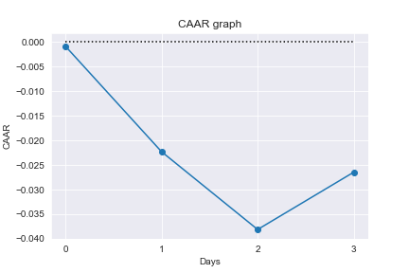

As previously mentioned, the $\overline{CAR}$ gradually drops throughout the event window. According to the efficient market hypothesis, prices incorporate all available information and when new information comes available, price should adjust immediately. However, the $\overline{CAR}$ has shown that from these events, the price did not adjust immediately; the $\overline{CAR}$ further drops after day 0 and reached the trough on day 3. This signifies that the market may be inefficient, and it took few more days for investors to react to the events. Another possibility is that the investors were expecting Tencent or the government to have further action regarding the events, which may be a possible reason for the insignificant impact of day 0 in the first and last event. The reason behind may be due to market do not find the events important, or there may be an occurrence insider trading. The insider trading can be examined in the following tables:

|  |  |  |  |  |  |  |
| --- | --- | --- | --- | --- | --- | --- |
| Date | ln_ret | ER | AR | AR Beta | CAR | CAR Beta |
| 09/08/2018 | 0.02335 | 0.01075 | 0.01261 | 1.1724 | 0.01261 | 0.82901 |
| 10/08/2018 | -0.007 | -0.01176 | 0.00476 | 0.44224 | 0.01736 | 1.14172 |

|  |  |  |  |  |  |  |
| --- | --- | --- | --- | --- | --- | --- |
| Date | ln_ret | ER | AR | AR Beta | CAR | CAR Beta |
| 29/08/2018 | -0.01267 | 0.00232 | -0.01499 | -1.39359 | -0.01499 | -0.98541 |
| 30/08/2018 | -0.00947 | -0.01238 | 0.00291 | 0.27056 | -0.01208 | -0.7941 |

|  |  |  |  |  |  |  |
| --- | --- | --- | --- | --- | --- | --- |
| Date | ln_ret | ER | AR | AR Beta | CAR | CAR Beta |
| 05/09/2018 | -0.04161 | -0.03533 | -0.00628 | -0.58427 | -0.00628 | -0.41314 |
| 06/09/2018 | -0.0319 | -0.01369 | -0.01821 | -1.69355 | -0.02449 | -1.61067 |

The tables have shown the abnormal returns of two days before the 3 events. The occurrence of insider trading will be revealed if the AR of either day in the insider trading window is statistically significant. Despite the AR of Day -1 in the last insider trading window is close to significance level, none of the AR are significant, suggesting no sign of insider trading in the events, even for the first and the last events which did not occur with a significant Day 1 AR.

With no insider trading occurring in any of the event windows, a possible explanation for the insignificance of day 1 in the first event can be the aforementioned reason of investors interpreting the new information. As for the last event, a possible cause for the insignificance in both the event window and the insider trading window is due to the event is insignificant, where investors expected the implementation of the verification system after the first two events. Another interpretation can be despite the event is a respond to the government intervention, it itself was a strategic choice conducted by Tencent, and possibly with the government. There is a likelihood that the choice is leaked by any of the party and reflected before the event and insider trading window.

# Further hypothesis testing

Further hypothesis testing is carried out to test whether the change is share price from the events are solely a fluctuation within Tencent, or it affects the whole game sector. The share price of NetEase, the second biggest gaming company in China will be tested in the same event windows. The AR can be examined with the market model, creating the linear relationship between the return of NetEase and the market index, NASDAQ. The result of the 3 events windows are as followed:

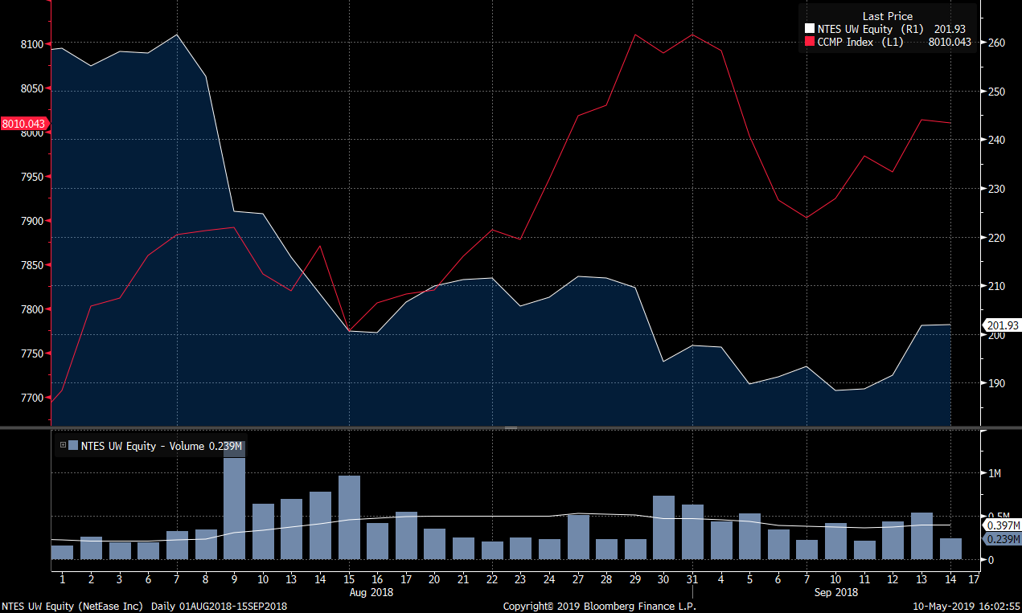

|  |  |  |  |  |  |  |
| --- | --- | --- | --- | --- | --- | --- |
| Date | ln_ret | ER | AR | AR Beta | CAR | CAR Beta |
| 13/08/2018 | -0.04033 | -0.00496 | -0.03537 | -1.89863 | -0.03537 | -0.94932 |
| 14/08/2018 | -0.03576 | 0.00453 | -0.04029 | -2.16297 | -0.07566 | -2.0308 |
| 15/08/2018 | -0.03699 | -0.01539 | -0.02159 | -1.15924 | -0.09725 | -2.61042 |
| 16/08/2018 | -0.002 | 0.00204 | -0.00403 | -0.21653 | -0.10128 | -2.71869 |

|  |  |  |  |  |  |  |
| --- | --- | --- | --- | --- | --- | --- |
| Date | ln_ret | ER | AR | AR Beta | CAR | CAR Beta |
| 31/08/2018 | 0.01693 | 0.00041 | 0.01653 | 0.88721 | 0.01653 | 0.4436 |
| 04/09/2018 | -0.00223 | -0.00473 | 0.0025 | 0.13425 | 0.01903 | 0.51073 |
| 05/09/2018 | -0.03887 | -0.01494 | -0.02392 | -1.28438 | -0.0049 | -0.13146 |
| 06/09/2018 | 0.00756 | -0.01194 | 0.01951 | 1.04715 | 0.01461 | 0.39211 |

|  |  |  |  |  |  |  |
| --- | --- | --- | --- | --- | --- | --- |
| Date | ln_ret | ER | AR | AR Beta | CAR | CAR Beta |
| 07/09/2018 | 0.01123 | -0.00504 | 0.01627 | 0.87355 | 0.01627 | 0.43678 |
| 10/09/2018 | -0.02599 | 0.00053 | -0.02652 | -1.42373 | -0.01025 | -0.27509 |
| 11/09/2018 | 0.00212 | 0.00406 | -0.00194 | -0.10413 | -0.01219 | -0.32716 |
| 12/09/2018 | 0.01472 | -0.00476 | 0.01949 | 1.04611 | 0.0073 | 0.1959 |

The AR will be statistically significant if the government interventions affected the share price of NetEase and the first event indeed showed significance in the hypothesis testing. The AR of day 0 of the first event was -0.03537, with the variance of 0.01863, the value of θ is -1.8986. It is statistically significant at 94% level of significance and thus rejecting the null hypothesis of the event has no impact on the share price of NetEase. The impact is strengthened in day 1 as the AR on day 1 decreased to -0.04029 and the value of θ decreased to -2.16297. The CAR on the first event as well showed significance, with the CAR on the last day in the event window of -0.10128, the value of θ is -2.71869, implying strong evidence against the null hypothesis. This can be interpreted as the event of taking down the big hit Monster Hunter did provide a deterrence effect, which is not only retained within Tencent but spread across the whole gaming sector. That said, despite being the second biggest gaming company in China, it is failed to reject the other events do not affect the share price of NetEase. A possible explanation is the US market already acknowledge the dominance and the attitude of the Chinese government towards the gaming sector within the first incident, where the government would and could do anything to intervene Tencent and the gaming sector if they must. To put it another way, the second and the third event did not exceed the expectation of the US market and hence the market did not recognise the importance of the events. As for the last event, since it was a policy change within Tencent's "Honour of the King" and at the same time, investors did not worry NetEase would take a similar approach, the event is insignificant to NetEase.

On the other hand, another non-gaming tech firm from China is going to be tested. Alibaba is the world largest e-commerce retailer from China. Share price in the same event window of another firm, Alibaba, is tested in order to demonstrate the interventions had impact on the gaming sector but not to other tech sectors. The result is as follow.

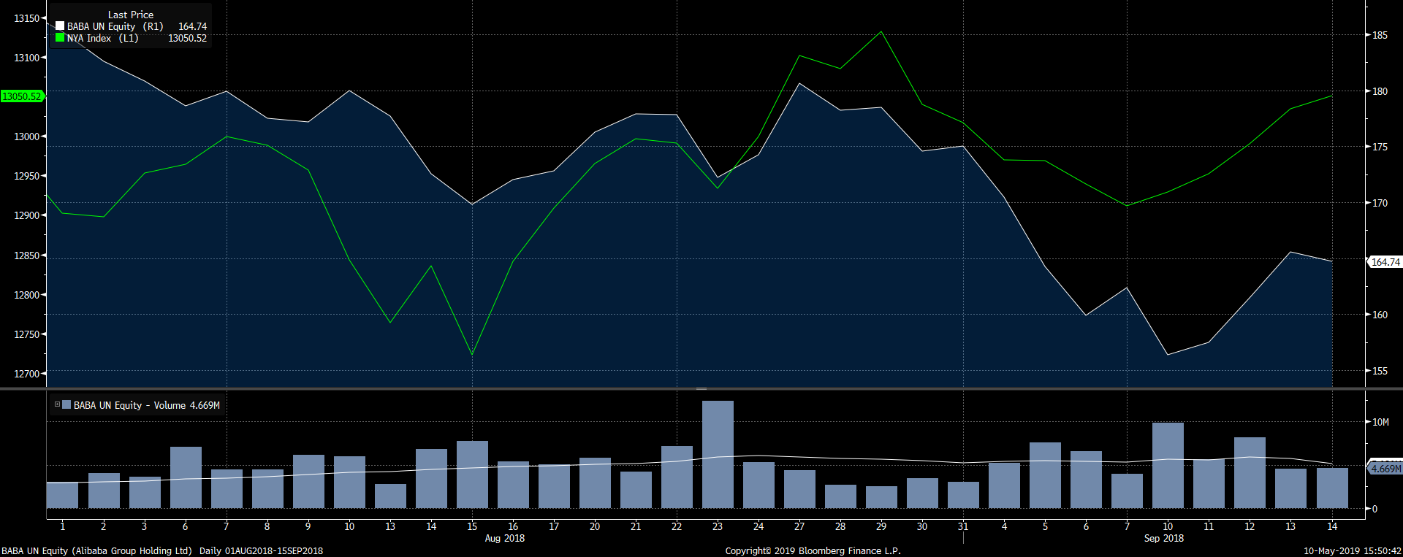

|  |  |  |  |  |  |  |
| --- | --- | --- | --- | --- | --- | --- |
| Date | ln_ret | ER | AR | AR Beta | CAR | CAR Beta |
| 13/08/2019 | -0.01303 | -0.0107 | -0.00233 | -0.14833 | -0.00233 | -0.07416 |
| 14/08/2019 | -0.02941 | 0.00972 | -0.03913 | -2.48955 | -0.04146 | -1.31894 |
| 15/08/2019 | -0.01577 | -0.01509 | -0.00068 | -0.04347 | -0.04214 | -1.34067 |
| 16/08/2019 | 0.01264 | 0.01601 | -0.00337 | -0.21452 | -0.04552 | -1.44794 |

|  |  |  |  |  |  |  |
| --- | --- | --- | --- | --- | --- | --- |
| Date | ln_ret | ER | AR | AR Beta | CAR | CAR Beta |
| 31/08/2018 | 0.00235 | -0.00299 | 0.00534 | 0.33958 | 0.00534 | 0.16979 |
| 04/09/2018 | -0.02646 | -0.00619 | -0.02027 | -1.28997 | -0.01494 | -0.4752 |
| 05/09/2018 | -0.03712 | -0.00012 | -0.037 | -2.35411 | -0.05194 | -1.65225 |
| 06/09/2018 | -0.02691 | -0.00389 | -0.02302 | -1.46454 | -0.07496 | -2.38452 |

|  |  |  |  |  |  |  |
| --- | --- | --- | --- | --- | --- | --- |
| Date | ln_ret | ER | AR | AR Beta | CAR | CAR Beta |
| 07/09/2018 | 0.01552 | -0.00365 | 0.01917 | 1.21948 | 0.01917 | 0.60974 |
| 10/09/2018 | -0.03772 | 0.0024 | -0.04012 | -2.55254 | -0.02095 | -0.66653 |
| 11/09/2018 | 0.00701 | 0.00321 | 0.0038 | 0.24186 | -0.01715 | -0.54561 |
| 12/09/2018 | 0.02509 | 0.00509 | 0.02 | 1.27247 | 0.00285 | 0.09063 |

Although most of the AR in the event windows are statistically significant, the AR and CAR of the second event is statistically significant. The AR of day 2 in the second event window was -0.3643 and the value of θ is -2.43829. The CAR is -0.07367 on the last day of the event window and the value of θ is -2.46519. This is possibly a result of both market inefficiency and the spillover effect of the policy change. This may be due to the market being inefficient and thus it took two days for the market to react. Meanwhile, the policy explained plans for limiting the use of electronics in general, which possibly lead to the spillover effect from the gaming sector to other tech sectors. Having said that, predominantly, the government interventions did not have significant impact on the share price of Alibaba as the impact is centred in the Tencent and the gaming sector but other tech sectors.

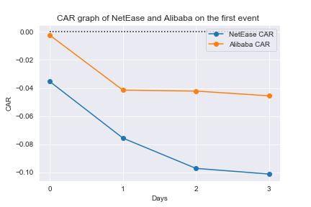

# 

# Limitation of the study and possible agenda for future

As with other stock price prediction models, the market model cannot precisely predict the stock price despite being the most optimal model for event study. This is due to the attribute of share price largely being random walk and depends on the news which is unexpected in nature. A solution for the future agenda can be testing with different statistical models and prediction models, including multi polynomial regression or stock price prediction model from machine learning. It may generate a more accurate stock price prediction which can more precisely evaluate the impact of the government intervention on the stock price.

The Shapiro-Wilk and Anderson-Darling tests were applied to the stock returns and market returns and showed both having low p values, implying non-normal distribution exists in both returns. However, the market model's linear specification follows from the assumed joint normality of the stock return and without assuming normality, the result of the analysis will be asymptotic. With that said, Mackinlay (1997) also mentioned that it is not problematic overall as convergence to the asymptotic distribution tend to be quick for event studies. In spite of that, in order to provide more rigorous evidence for the impact of the government interventions, a non-parametric test, for instance, a sign test or rank test can be implemented into the study in future, along with the parametric tests. This allows the robustness of the conclusions of the parametric test to be re-examined, which may provide a more reliable inference, compare to the standard parametric test (MACKINLAY, 1997).

A potential bias may occur in the correlation between the market return and the stock return. This is due to Tencent is one of the constituent stocks of the Hang Seng Index and hence the movement of Hang Seng index will be influence by the fluctuation of price of Tencent. With the market cap of $3.697 Trillion HKD, the weight of Tencent in the Hang Seng Index is 0.1093, suggesting strong correlation with the Hang Seng index. A possible solution for future research will be referencing a index that is able to reflect the market return of the Hang Seng index while exclude the return of Tencent.

# Conclusion

Along with the overall pessimistic investing atmosphere of gaming sector of China in 2018, the government interventions had a significant impact on the share price of Tencent. With the event study, both pull down of the big hit Monster Hunter and the pronouncement from the Ministry of Education has shown significance in influencing the Tencent's stock price. There was also a possible existence of insider trading in the last event of Tencent's announcement of implementing real name verification to their biggest hits "Honour of the Kings". Regardless the market reacted instantly or with a delay, the events have shown significant impact to the share price, which in turns suggests that the slump in share price after the event are not by chance but likely due to the government interventions. Market efficiency in the events also has shown the market loosely achieves the semi-strong form of market efficiency, where share price adjusts incautiously to available new information. Nevertheless, it was unable to concisely indicate the change in share price of Tencent due to the government intervention is not merely a fluctuation of Tencent price. An absent of high fluctuations of stock prices due to the interventions were observed in the gaming sector. However, we do not observe similar effects extending to other non-gaming tech firms. Nevertheless, the long-term impact of the events may be more ambiguous, as at the time of writing, the Tencent have already reclaimed half of its losses in half a year and PUBG can finally be monetised after a year of release.